WEEK 7

9. ReactJS

ListOfPlayers.js

import React from 'react';

function ListOfPlayers() {

  const players = [

    { name: "Virat", score: 85 },

    { name: "Rohit", score: 60 },

    { name: "Rahul", score: 45 },

    { name: "Jadeja", score: 95 },

    { name: "Pant", score: 78 },

    { name: "Dhoni", score: 120 },

    { name: "Shami", score: 25 },

    { name: "Bumrah", score: 72 },

    { name: "Ashwin", score: 38 },

    { name: "Iyer", score: 80 },

    { name: "Gill", score: 90 },

  ];

  const filtered = players.filter(p => p.score < 70);

  return (

    <div>

      <h2>All Players:</h2>

      {players.map((p, i) => (

        <p key={i}>{p.name} - {p.score}</p>

      ))}

      <h3>Players with score below 70:</h3>

      {filtered.map((p, i) => (

        <p key={i}>{p.name} - {p.score}</p>

      ))}

    </div>

  );

}

export default ListOfPlayers;

IndianPlayers.js

import React from 'react';

function IndianPlayers() {

  const T20 = ['Virat', 'Rohit', 'Pant', 'Hardik'];

  const Ranji = ['Pujara', 'Rahane', 'Iyer'];

  const merged = [...T20, ...Ranji];

  const [first, second, ...rest] = merged;

  return (

    <div>

      <h2>Odd & Even Team Players</h2>

      <p>Odd: {first}</p>

      <p>Even: {second}</p>

      <p>Others: {rest.join(", ")}</p>

    </div>

  );

}

export default IndianPlayers;

App.js

import React from 'react';

import ListOfPlayers from './ListOfPlayers';

import IndianPlayers from './IndianPlayers';

function App() {

  const flag = true;

  return (

    <div>

      {flag ? <ListOfPlayers /> : <IndianPlayers />}

    </div>

  );

}

export default App;

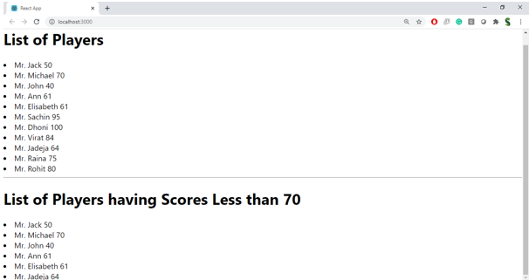

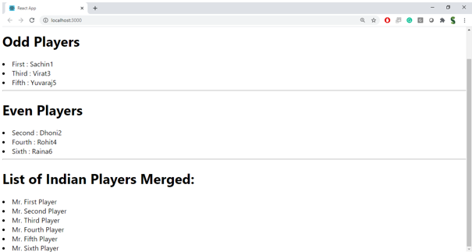

10. ReactJS

App.js

import React from 'react';

function App() {

  const offices = [

    { name: "CozySpace", rent: 55000, address: "Chennai" },

    { name: "SmartOffice", rent: 75000, address: "Bangalore" },

    { name: "WorkNest", rent: 40000, address: "Hyderabad" }

  ];

  return (

    <div>

      <h1 style={{ color: "navy" }}>Office Space Rental</h1>

      <img src="https://via.placeholder.com/300x150" alt="Office" />

      {offices.map((office, index) => (

        <div key={index}>

          <h2>{office.name}</h2>

          <p>Address: {office.address}</p>

          <p style={{ color: office.rent > 60000 ? "green" : "red" }}>

            Rent: ₹{office.rent}

          </p>

        </div>

      ))}

    </div>

  );

}

export default App;

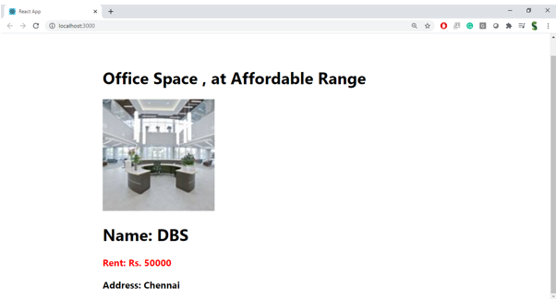

11. ReactJS

App.js

import React, { useState } from 'react';

function App() {

  const [count, setCount] = useState(0);

  const [rupees, setRupees] = useState("");

  const [euro, setEuro] = useState("");

  const increment = () => {

    setCount(count + 1);

    sayHello();

  };

  const decrement = () => {

    setCount(count - 1);

  };

  const sayHello = () => {

    alert("Hello! Button was clicked.");

  };

  const sayWelcome = (msg) => {

    alert("Welcome message: " + msg);

  };

  const handleConvert = () => {

    const result = (parseFloat(rupees) / 90).toFixed(2);

    setEuro(result);

  };

  return (

    <div>

      <h2>Counter: {count}</h2>

      <button onClick={increment}>Increment</button>

      <button onClick={decrement}>Decrement</button>

      <br /><br />

      <button onClick={() => sayWelcome("Welcome to the Event Example!")}>Say Welcome</button>

      <br /><br />

      <button onClick={() => alert("I was clicked!")}>OnPress</button>

      <br /><br />

      <h2>Currency Converter</h2>

      <input type="text" placeholder="INR" value={rupees} onChange={(e) => setRupees(e.target.value)} />

      <button onClick={handleConvert}>Convert</button>

      <p>In Euros: €{euro}</p>

    </div>

  );

}

export default App;

12. 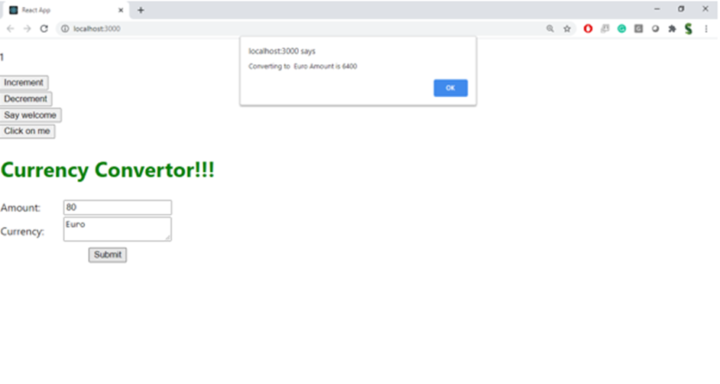

12. ReactJS

App.js

import React, { useState } from 'react';

function App() {

  const [isLoggedIn, setIsLoggedIn] = useState(false);

  const handleLogin = () => setIsLoggedIn(true);

  const handleLogout = () => setIsLoggedIn(false);

  return (

    <div>

      <h1>Flight Ticket Booking</h1>

      {isLoggedIn ? (

        <div>

          <h2>Welcome, User!</h2>

          <button onClick={handleLogout}>Logout</button>

          <p>You can now book your flight tickets.</p>

        </div>

      ) : (

        <div>

          <h2>Hello, Guest!</h2>

          <button onClick={handleLogin}>Login</button>

          <p>You can only view flight details.</p>

        </div>

      )}

    </div>

  );

}

export default App;

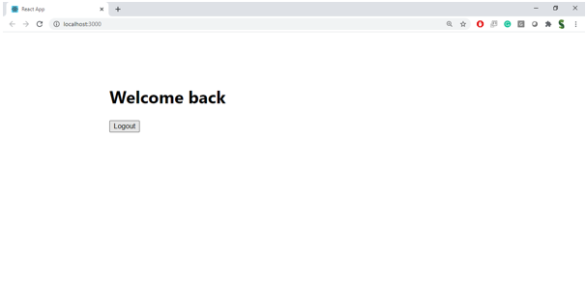

13. ReactJS

BookDetails.js

import React from 'react';

export default function BookDetails() {

  return <h2>Book Details Component</h2>;

}

BlogDetails.js

import React from 'react';

export default function BlogDetails() {

  return <h2>Blog Details Component</h2>;

}

CourseDetails.js

import React from 'react';

export default function CourseDetails() {

  return <h2>Course Details Component</h2>;

}

App.js

import React, { useState } from 'react';

import BookDetails from './BookDetails';

import BlogDetails from './BlogDetails';

import CourseDetails from './CourseDetails';

function App() {

  const [choice, setChoice] = useState("book");

  return (

    <div>

      <h1>Blogger App</h1>

      <button onClick={() => setChoice("book")}>Book</button>

      <button onClick={() => setChoice("blog")}>Blog</button>

      <button onClick={() => setChoice("course")}>Course</button>

      {choice === "book" && <BookDetails />}

      {choice === "blog" && <BlogDetails />}

      {choice === "course" && <CourseDetails />}

    </div>

  );

}

export default App;

